PROGRAM-3

Q. Design and implement an algorithm for conversion of an expression from one form to another. Demonstrate its working with suitable inputs.

- Conversion of INFIX expression to POSTFIX expression

- Theory:

Postfix Expression:
When the operator is written after the operands, then it is known as postfix notation. Operand does not have to be always a constant or a variable; it can also be an expression itself.

The syntax for postfix notation is given below:
<operand> <operand> <operator>
Example:
∗ + a b + c d
Infix Expression:
When the operator is written in between the operands, then it is known as infix notation. Operand does not have to be always a constant or a variable; it can also be an expression itself.
Example:
(p + q) * (r + s)
Infix notation’s syntax is:
<operand> <operator> <operand>

//--------------------------------------------------------------------------------

Example: Convert the given INFIX to POSTFIX expression:
a+b*(c^d-e)^(f+g*h)-i

Input | Stack | Postfix Expression
a |  | a
+ | + | a
b | + | ab
* | +* | ab
( | +*( | ab
c | +*( | abc
^ | +*(^ | abc
d | +*(^ | abcd
- | +*(- | abcd^
e | +*(- | abcd^e
) | +* | abcd^e-
^ | +*^ | abcd^e-
( | +*^( | abcd^e-
f | +*^( | abcd^e-f
+ | +*^(+ | abcd^e-f
g | +*^(+ | abcd^e-fg
* | +*^(+* | abcd^e-fg
h | +*^(+* | abcd^e-fgh
) | +*^ | abcd^e-fgh*+
- | - | abcd^e-fgh*+^*+
i | - | abcd^e-fgh*+^*+i  abcd^e-fgh*+^*+i-

The postfix expression thus obtained is
abcd^e-fgh*+^*+i-
//-------------------------------------------------------------
- Algorithm:
Step-1: Print the operand as they arrive.
Step-2: If the stack is empty or contains a left parenthesis on top, push the incoming operator on to the stack.
Step-3: If the incoming symbol is '(', push it on to the stack.
Step-4: If the incoming symbol is ')', pop the stack and print the operators until the left parenthesis is found.
Step-5: If the incoming symbol has higher precedence than the top of the stack, push it on the stack.
Step-6: If the incoming symbol has lower precedence than the top of the stack, pop and print the top of the stack. Then test the incoming operator against the new top of the stack.
Step-7: If the incoming operator has the same precedence with the top of the stack then use the associativity rules. If the associativity is from left to right then pop and print the top of the stack then push the incoming operator. If the associativity is from right to left then push the incoming operator.
Step-8: At the end of the expression, pop and print all the operators of the stack.
//----------------------------------------------------------------------------

- Code:

#include<stdio.h>
#include<stdlib.h> //including various header files
#include<string.h>
#include<ctype.h>
// char stack
char stack[50]; // stack is defined with size 25
int top=-1; // top of the stack is initialized to -1
void push(char item) // function for push
{
stack[++top]=item;
}
char pop() // function for pop
{
return stack[top--];
}

int precedence(char symbol) // function to check precedences of operators
{
switch(symbol) // switch case to check whether it is symbol or not
{
case '+':
case '-': return 2;
break;
case '*':
case '/': return 3; // precedence is checked for different symbols like +,_,*,/,^
break; // generally parenthesis have the highest precedence
case '^': return 4;
break;
case ')':
case '(':
case '#': return 1;
break;
}
}
int isOperator(char symbol) // function written to check the operator provided by the user
{
switch(symbol) //switch case to determine the symbol
{
case '+':
case '-':
case '*':
case '/': // operators consists of +,-,*,/,^
case '^':
case ')':
case '(': return 1;
break;
default : return 0; //any other symbol entered states invalid and returns 0
}
}

void convert(char infix[], char postfix[]) // convert the infix to postfix expression
{
int i,j=0,symbol; // i,j and symbol is intialized
stack[++top] = '#';
for(i=0;i<strlen(infix);i++) //for loop to check the length of the string
{
symbol=infix[i]; // infix expression is assigned to symbol
if(isOperator(symbol)==0) // if function isoperator returns 0
{
postfix[j] = symbol; //then symbol is assigned to postfix string
j++; //j is incremented
}
else
{
if (symbol=='(') // if open paranthesis occurs
{
push(symbol); //push it into the stack
}
else //else
{
if (symbol==')') // if close parenthesis occurs
{
while(stack[top] !='(') //till we found an open parenthesis
{
postfix[j] = pop(); //pop the operators and assign them or add them to postfix expression till we find a open parenthesis
j++; //j is incremented
}
pop(); // pop function is called
}

else
{
if (precedence(symbol)>precedence(stack[top])) // if precedence of symbol is greater than top of the stack
{
push(symbol); //push the symbol into the stack
}
else
{
while(precedence(symbol)<=precedence(stack[top])) //if precedence of symbol is greater than or equal to top of the stack
{
postfix[j]=pop(); //pop the opeartors
j++;
}
push(symbol); //rest all other opeartors are pushed
}
}
}
}
}
while(stack[top]!='#') //# defines nothing or the end of the stack
{
postfix[j] = pop();
j++;
}
postfix[j]='\0'; //finally the postfix expression is terminated by null character
}

void main() //main function
{
char infix[30]="1+(2*3)",postfix[30];
//infix,postfix strings are intialized of size 30 and an infix expression is self-given by the user
convert (infix, postfix); //convert function is called to convert the infix to postfix expression.
printf("the infix expression is %s\n",infix); //infix expression is printed on the console
printf("the postfix expression is %s\n",postfix); //postix expression is printed on the console
}
//END OF THE PROGRAM

//----------------------------------------------------------------------------

“SCREENSHOT OF THE OUTPUT”

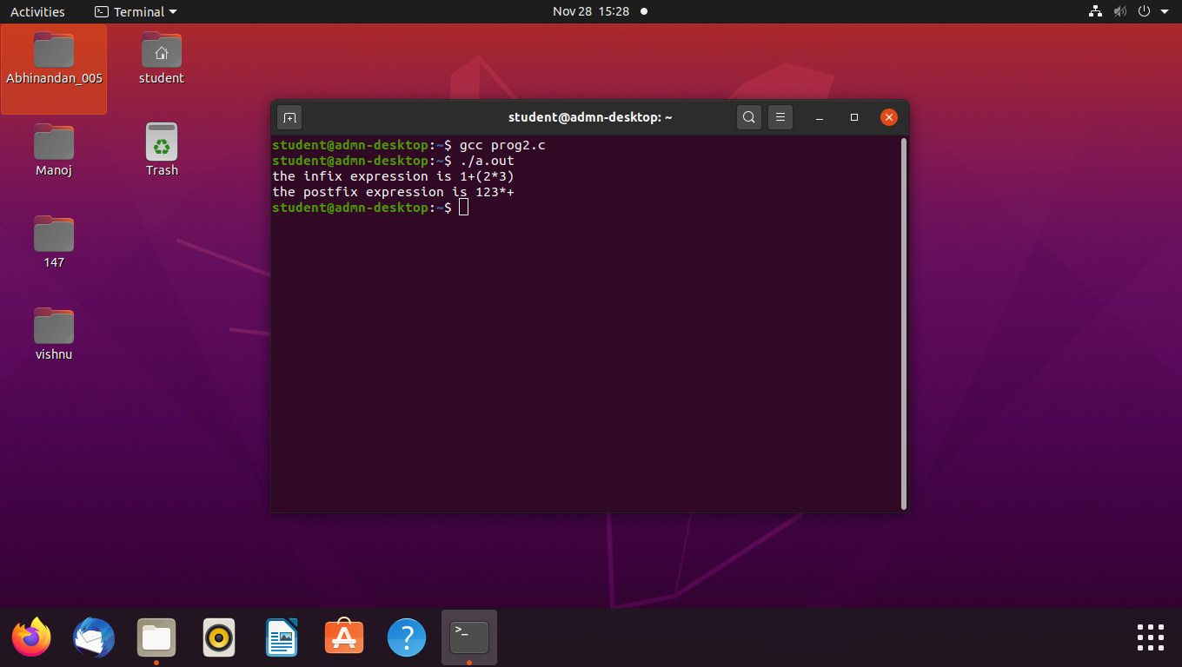

//-------------------------------------------------------------------------------

- Conversion from INFIX expression to PREFIX expression

- Theory:

Infix Expression:

When the operator is written in between the operands, then it is known as infix notation. Operand does not have to be always a constant or a variable; it can also be an expression itself.

Example:
(p + q) * (r + s)
Infix notation’s syntax is:
<operand> <operator> <operand>

Prefix Expression:
Another way to describe anything is with a prefix notation, which does not require knowledge about precedence or associativity but does when used with an infix notation. It is also known as polish notation. In prefix notation, an operator comes before the operands.

The syntax of prefix notation is given below:
<operator> <operand> <operand>
Example:
a b + c d + ∗
Convert the given Infix expression to Prefix expression:
K + L - M * N + (O^P) * W/U/V * T + Q

To convert this expression to start with, according to the algorithm we need to reverse the given expression.

The Reverse expression of the given problem is:
Q + T * V/U/W * ) P^O(+ N*M - L + K

Input expression | Stack | Prefix expression
Q |  | Q
+ | + | Q
T | + | QT
* | +* | QT
V | +* | QTV
/ | +*/ | QTV
U | +*/ | QTVU
/ | +*// | QTVU
W | +*// | QTVUW
* | +*//* | QTVUW
) | +*//*) | QTVUW
P | +*//*) | QTVUWP
^ | +*//*)^ | QTVUWP
O | +*//*)^ | QTVUWPO
( | +*//* | QTVUWPO^
+ | ++ | QTVUWPO^*//*
N | ++ | QTVUWPO^*//*N
* | ++* | QTVUWPO^*//*N
M | ++* | QTVUWPO^*//*NM
- | ++- | QTVUWPO^*//*NM*
L | ++- | QTVUWPO^*//*NM*L
+ | ++-+ | QTVUWPO^*//*NM*L
K | ++-+ | QTVUWPO^*//*NM*LK
 |  | QTVUWPO^*//*NM*LK+-++

QTVUWPO^*//*NM*LK+-++ is the obtained POSTFIX expression.
Now, reverse the postfix expression to get the PREFIX expression.
++-+KL*MN*//*^OPWUVTQ is the required PREFIX expression.

//--------------------------------------------------------------------------------------------

- Algorithm:
Step-1: First, reverse the infix expression given in the problem.
Step-2: Scan the expression from left to right.
Step-3: Whenever the operands arrive, print them.
Step-4: If the operator arrives and the stack is found to be empty, then simply push the operator into the stack.
Step-5: If the incoming operator has higher precedence than the TOP of the stack, push the incoming operator into the stack.
Step-6: If the incoming operator has the same precedence with a TOP of the stack, push the incoming operator into the stack.
Step-7: If the incoming operator has lower precedence than the TOP of the stack, pop, and print the top of the stack. Test the incoming operator against the top of the stack again and pop the operator from the stack till it finds the operator of a lower precedence or same precedence.
Step-8: If the incoming operator has the same precedence with the top of the stack and the incoming operator is ^, then pop the top of the stack till the condition is true. If the condition is not true, push the ^ operator.
Step-9: When we reach the end of the expression, pop, and print all the operators from the top of the stack.
Step-10: If the operator is ')', then push it into the stack.
Step-11: If the operator is '(', then pop all the operators from the stack till it finds) opening bracket in the stack.
Step-12: If the top of the stack is ')', push the operator on the stack.
Step-13: At the end, reverse the output.
//-------------------------------------------------------------------------------------

- Code:

# include <stdio.h>
# include <string.h>
# define MAX 100
#include<ctype.h>
void infixtoprefix(char infix[20],char prefix[20]);
void rev(char arr[30]);
char pop();
void push(char symbol);
int isOperator(char symbol);
char prcd(symbol);
int top=-1;
char stack[MAX];
int main() {
char infix[20],prefix[20],temp;
printf("Enter infix expression:");
scanf("%s",infix);
infixtoprefix(infix,prefix);
rev(prefix);
printf("the prefix expression is %s\n",prefix);
}
//--------------------------------------------------------
void infixtoprefix(char infix[20],char prefix[20]) {
int i,j=0;
char symbol;
stack[++top]='#';
rev(infix);
for (i=0;i<strlen(infix);i++) {
symbol=infix[i];
if (isOperator(symbol)==0) {
prefix[j]=symbol;
j++;
} else {
if (symbol==')') {
push(symbol);
} else if(symbol == '(') {
while (stack[top]!=')') {
prefix[j]=pop();
j++;
}
pop();
} else {
if (prcd(stack[top])<=prcd(symbol)) {
push(symbol);
} else {
while(prcd(stack[top])>=prcd(symbol)) {
prefix[j]=pop();
j++;
}
push(symbol);
}
//end for else
}
}
//end for else
}
//end for for
while (stack[top]!='#') {
prefix[j]=pop();
j++;
}
prefix[j]='\0';
}
////--------------------------------------------------------
void rev(char arr[30])
{
int i,j;
char temp[100];
for (i=strlen(arr)-1,j=0;i+1!=0;--i,++j) {
temp[j]=arr[i];
}
temp[j]='\0';
strcpy(arr,temp);
return arr;
}
//--------------------------------
char pop() {
char a;
a=stack[top];
top--;
return a;
}
//----------------------------------
void push(char symbol) {
top++;
stack[top]=symbol;
}
//------------------------------------------
char prcd(symbol)
{
switch(symbol) {
case '+':
case '-':
return 2;
break;
case '*':
case '/':
return 4;
break;
case '$':
case '^':
return 6;
break;
case '#':
case '(':
case ')':
return 1;
break;
}
}
//-------------------------------------------------
int isOperator(char symbol) {
switch(symbol) {
case '+':
case '-':
case '*':
case '/':
case '^':
case '$':
case '&':
case '(':
case ')':
return 1;
break;
default:
return 0;
// returns 0 if the symbol is other than given above
}
}

“SCREENSHOT OF THE OUTPUT”

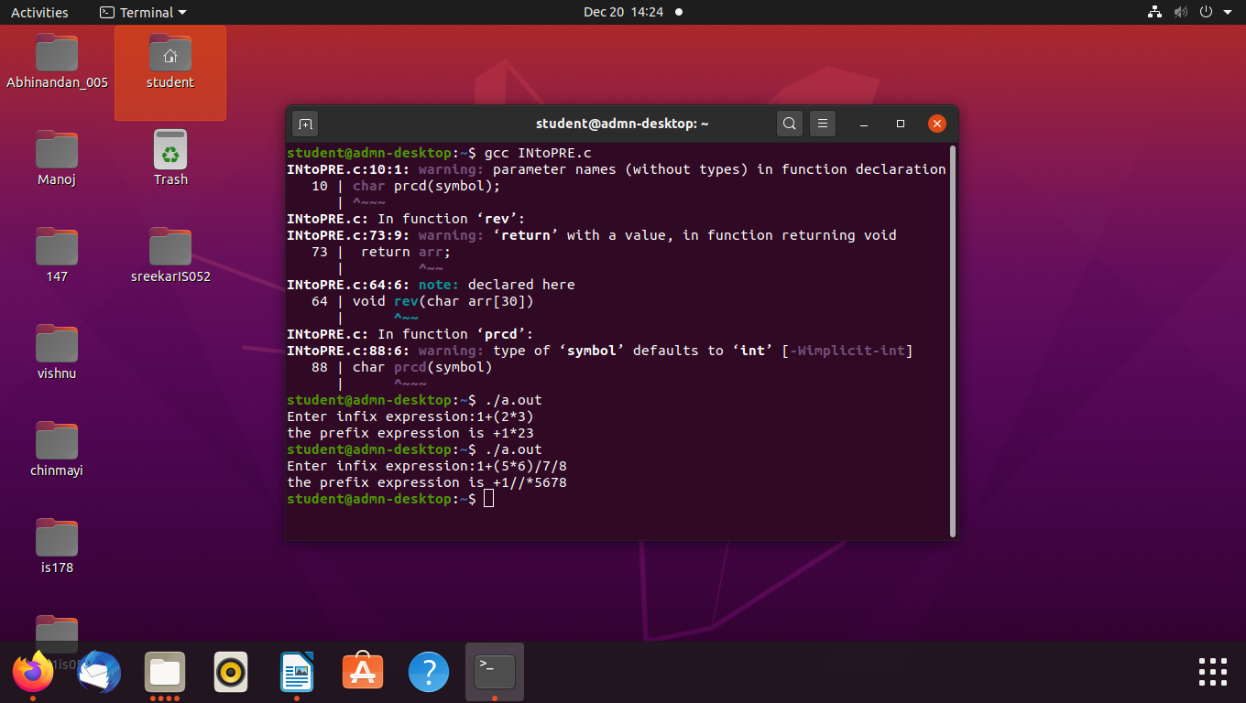

//-----------------------------------------------------------------------------------

- Conversion from PREFIX expression to POSTFIX expression

- Theory:
Prefix expression:
Another way to describe anything is with a prefix notation, which does not require knowledge about precedence or associativity but does when used with an infix notation. It is also known as polish notation. In prefix notation, an operator comes before the operands.

The syntax of prefix notation is given below:
<operator> <operand> <operand>
Example:
a b + c d + ∗
Postfix Expression:
When the operator is written after the operands, then it is known as postfix notation. Operand does not have to be always a constant or a variable; it can also be an expression itself.

The syntax for postfix notation is given below:
<operand> <operand> <operator>
Example:
∗ + a b + c d
//----------------------------------------------------------------------------------
Example: Convert the given expression from PREFIX to POSTFIX.
If the expression is: * - A / B C - / A K L

Symbols to be scanned | Action | Stack | Description
L | Push L into the stack | L
K | Push K into the stack | L, K
A | Push A into the stack | L, K, A
/ | Pop A from the stack  Pop K from the stack  Push A K / into the stack | L, A K / | Pop two operands from the stack, i.e., A and K. Add '/' operator after K operand, i.e., AK/. Push AK/ into the stack.
- | Pop A K / and L from the stack.  Push (A K / L -) into the stack | A K / L - | Pop two operands from the stack, i.e., AK/ and L. Add '-' operator after 'L' operand.
C | Push C into the stack | AK/L-, C
B | Push B into the stack | AK/L-, C, B
/ | Pop B and C from the stack.  Push BC/ into the stack. | AK/L-, BC/ | Pop two operands from the stack, i.e., B and C. Add '/' operator after C operator, i.e., BC/. Push BC/ into the stack.
A | Push A into the stack | AK/L-, BC/, A
- | Pop BC/ and A from the stack. Push ABC/- into the stack. | AK/L-, ABC/- | Pop two operands from the stack, i.e., A and BC/. Add '-' operator after '/'.
* | Pop ABC/- and AK/L- from the stack. Push ABC/AK/L-* into the stack. | ABC/-AK/L-* | Pop two operands from the stack, i.e., ABC/-, and AK/L- . Add '*' operator after L and '-' operator, i.e., ABC/-AK/L-*.

ABC/-AK/L-* is the required POSTFIX expression.

//-----------------------------------------------------------------------------------
- Algorithm:
Step-1: Scan the prefix expression from right to left, i.e., reverse.
Step-2: If the incoming symbol is an operand then push it into the stack.
Step-3: If the incoming symbol is an operator then pop two operands from the stack. Once the operands are popped out from the stack, we add the incoming symbol after the operands. When the operator is added after the operands, then the expression is pushed back into the stack.
Step-4: Once the whole expression is scanned, pop and print the postfix expression from the stack.
//-----------------------------------------------------------------------------------
- Code:
#include<stdio.h>
#include<conio.h>
#include<string.h>
#include<stdlib.h>
# define MAX 20
char str[MAX],stack[MAX];
int top=-1;
void push(char c)
{
stack[++top]=c;
}
char pop()
{
return stack[top--];
}
void pretopost()
{
int n,i,j=0; char c[20];
char a,b,op;
printf("Enter the prefix expression\n");
gets(str);
n=strlen(str);
for(i=0;i<MAX;i++)
stack[i]='\0';
printf("Postfix expression is:\t");
for(i=0;i<n;i++)
{
if(str[i]=='+'||str[i]=='-'||str[i]=='*'||str[i]=='/')
{
push(str[i]);
}
else
{ c[j++]=str[i];
while((top!=-1)&&(stack[top]=='#'))
{
a=pop(); c[j++]=pop();
}
push('#');
}
}
c[j]='\0';
printf("%s",c);
}
main()
{
pretopost();
}
//-----------------------------------------------------------------------------------

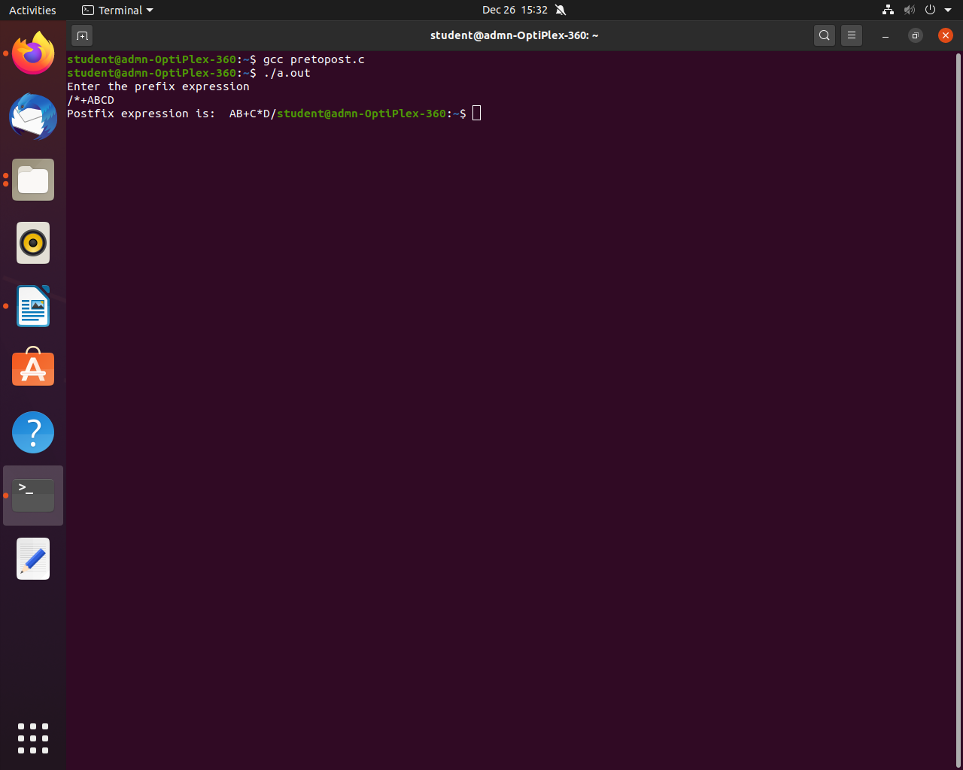
//-----------------------------------------------------------------------------------
- Conversion from POSTFIX expression to PREFIX expression.

- Theory:
Prefix Expression:
Another way to describe anything is with a prefix notation, which does not require knowledge about precedence or associativity but does when used with an infix notation. It is also known as polish notation. In prefix notation, an operator comes before the operands.

The syntax of prefix notation is given below:
<operator> <operand> <operand>
Example:
a b + c d + ∗

Postfix Expression:
When the operator is written after the operands, then it is known as postfix notation. Operand does not have to be always a constant or a variable; it can also be an expression itself.

The syntax for postfix notation is given below:
<operand> <operand> <operator>
Example:
∗ + a b + c d
//-----------------------------------------------------------------------------
Example: Convert the given expression from POSTFIX to PREFIX:
AB + CD - *
Symbol Scanned | Action | Stack | Description
A | Push A into the stack | A
B | Push B into the stack | AB
+ | Pop B from the stack  Pop A from the stack  Push +AB into the stack. | +AB | Pop two operands from the stack, i.e., A and B. Add '+' operator before the operands AB, i.e., +AB.
C | Push C into the stack | +ABC
D | Push D into the stack | +ABCD
- | Pop D from the stack.  Pop C from the stack.  Push -CD into the stack | +AB -CD | Pop two operands from the stack, i.e., D and C. Add '-' operator before the operands CD, i.e., -CD.
* | Pop -CD from the stack.  Pop +AB from the stack.  Push *+AB -CD into the stack. | *+AB - CD | Pop two operands from the stack, i.e., -CD and +AB. Add '*' operator before +AB then the expression would become *+AB-CD.

*+AB-CD is the obtained PREFIX expression.

//-----------------------------------------------------------------------------

- Algorithm:
Step-1: Scan the postfix expression from left to right.
Step-2: If the element is an operand, then push it into the stack.
Step-3: If the element is an operator, then pop two operands from the stack.
Step-4: Create an expression by concatenating two operands and adding operator before the operands.
Step-5: Push the result back to the stack.
Step-6: Repeat the above steps until we reach the end of the postfix expression.
//-----------------------------------------------------------------------------
- Code:
#include<stdio.h>
#include<string.h>
#include<stdlib.h>
#define MAX 20
char str[MAX], stack[MAX];
int top = -1;
//----------------------------------------------------------------------------------

void push (char c)
{
stack[++top] = c;
}
//----------------------------------------------------------------------------------

char pop()
{
return stack[top--];
}
//-----------------------------------------------------------------------------------

// A utility function to check if the given character is operand
int checkIfOperand(char ch)
{
return (ch >= 'a' && ch <= 'z') || (ch >= 'A' && ch <= 'Z');
}

//-----------------------------------------------------------------------------------

//function to check if it is an operator
int isOperator(char x)
{
switch (x) {
case '+':
case '-':
case '/':
case '*':
return 1;
}
return 0;
}
//----------------------------------------------------------------------------------
void postfixToprfix()
{
int n, i, j = 0;
char c[20];
char a, b, op;
printf("Enter the postfix expression\n");
scanf("%s", str);
n = strlen(str);
for (i = 0; i < MAX; i++)
stack[i] = '\0';
printf("Prefix expression is:\t");
for (i = n - 1; i >= 0; i--)
{
if (isOperator(str[i]))
{
push(str[i]);
} else
{
c[j++] = str[i];
while ((top != -1) && (stack[top] == '#'))
{
a = pop();
c[j++] = pop();
}
push('#');
}
}
c[j] = '\0';
i = 0;
j = strlen(c) - 1;
char d[20];
while (c[i] != '\0') {
d[j--] = c[i++];
}
printf("%s\n", d);
}
//-----------------------------------------------------------------------------------
int main()
{
postfixToprfix();
return 0;
}
//-----------------------------------------------------------------------------------

“SCREENSHOT OF THE OUTPUT”

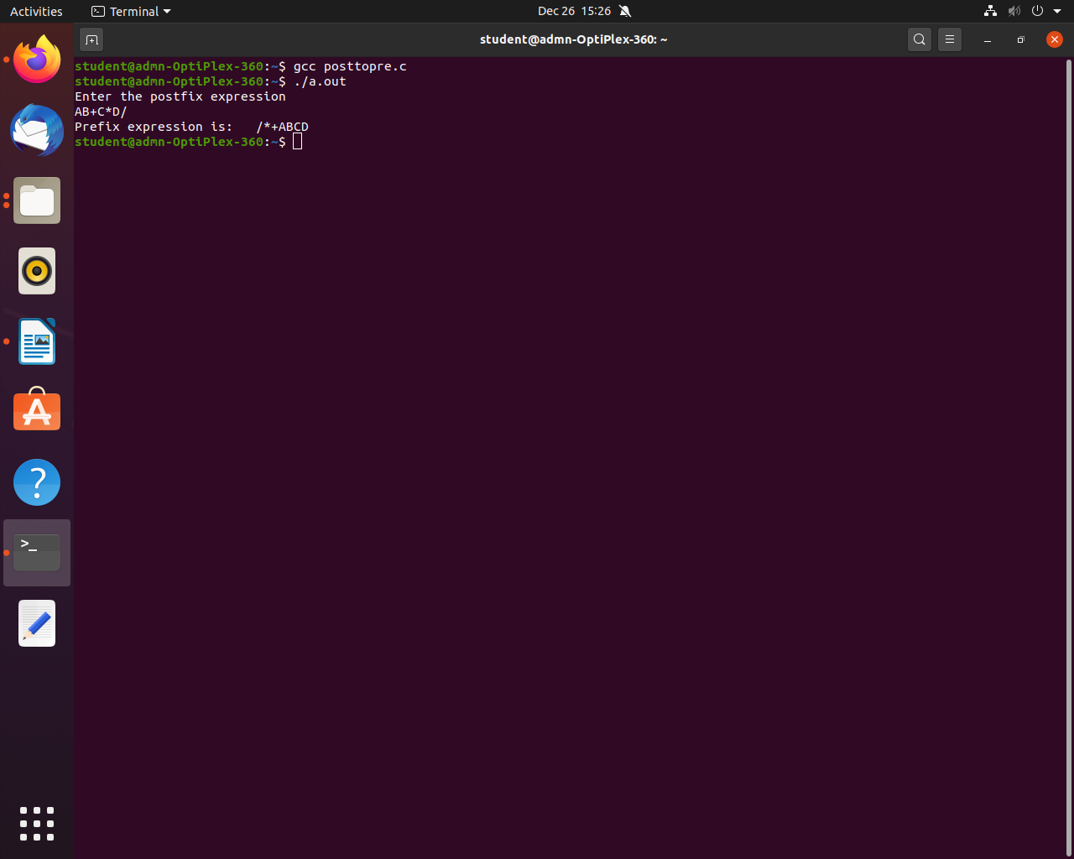

**********************************END***********************************

